Chung-Sung-Gok (청성곡)

Initially created for voice, Chung-Sung-Gok has long since evolved into a solo piece for bamboo flutes (danso, short bamboo flute, or dae-geum, long bamboo flute). Throughout the song are contrasting phrases between long sustained notes and clusters of grace notes that accentuate the clear, tonal quality of the bamboo flute.
The following are excerpts of an article by Professor Emeritus Usoc Shur (Professor Emeritus, Seoul National University College of Music) “Discourse Analysis of ChungSung-Gok (청성곡의 담론적 분석)”
http://usoc.snu.ac.kr/report-site/usoc-surh/yo-chun-all.htm

Abstract:
In music, as in linguistic text, the smallest unit is a tone, a single tone by one finger on piano. And largest unit is discourse, the whole musical piece to say movement. This paper purposed to prove that the very lower level of musical structure could decide the content of most higher level of music. In case of Chung-Sung-Gok (청성곡), grace notes at the end of a long note, have a function of erasing the memory of long note's pitch perception in our memory system, so the following long note could not make interval perception with preceding note.
I made melodic line of Chung-Sung-Gok (청성곡) into graph and addressed by letter name. When you listen, you can feel easily the group of grace notes erasing your perception of pitch sense of the note and could not make a interval perception between two notes, before graces and after graces.

Excerpt of his articles:
This is the original notation of Chung-Sung-Gok. The blue highlighted theme from the first jang (phrase: 1-jang), measures 4-12, is repeated in the second line (the second line of the first jang), measures 10-15, with omission of beats marked as ˅ or ˄ (in blue). It appears that long notes on the first line are shortened in the second line as the melody repeats. Green highlights are repeated in the endings of the first, second, and fifth jang. Because of repeating the motif with variation and insertion of new parts the entire piece becomes interesting.
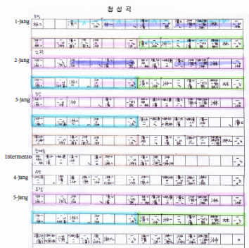

Graphic Notation of Chung-Sung-Gok
Since it is not easy to appreciate thematic repetition by listening to the recording the following graph was constructed using the PRAAT software. Then the graph was modified to include the names of long notes. Red boxes were added to indicate grace notes between said long notes. This graph illustrates the melodic progression visually.

The long notes in the first and second parts of the second jang (2장1 and 2장2) are nearly identical, with the only differences coming from the grace notes decorating the beginning part of each section. Because of these variations in grace notes, it is difficult to hear such similarities between the first and second jang. The grace notes before 林 in the first line of first jang (1장1) interferes with the flow of notes to 潢. Another big grace note after 潢 again interferes flow into the next note 㳞. I will call this the “adhesive articulator”, though it may be considered a “separator” or “preventor” [sic]. These articulators appear before or after long notes, similar to prefixes or suffixes. However, in the second part of the second jang (2장2), the articulators between notes 潢-潕are more than prefixes/suffixes; rather, these are independent articulators or interpolated separators. As a result the audience may not recognize the repetition of the melody and cannot predict the coming melodic progression.
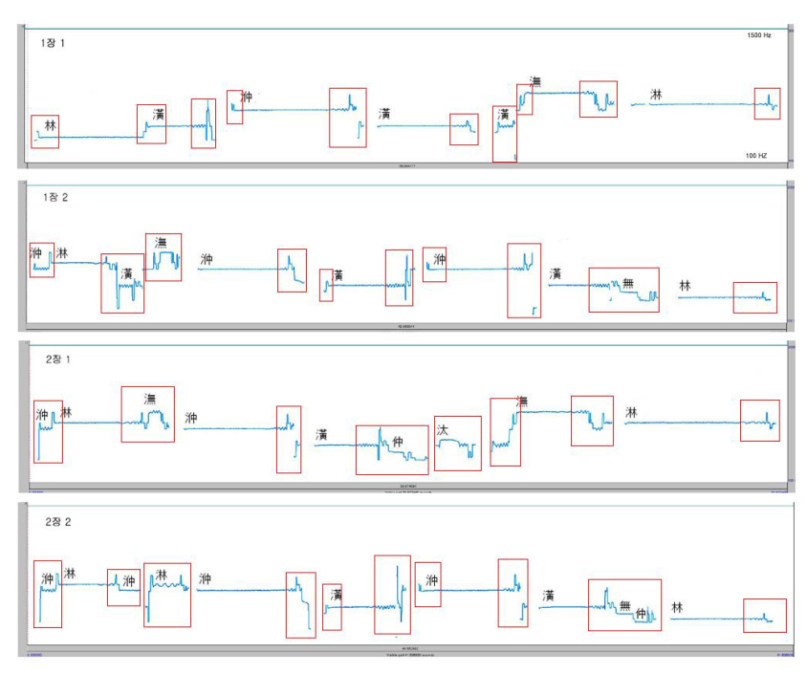
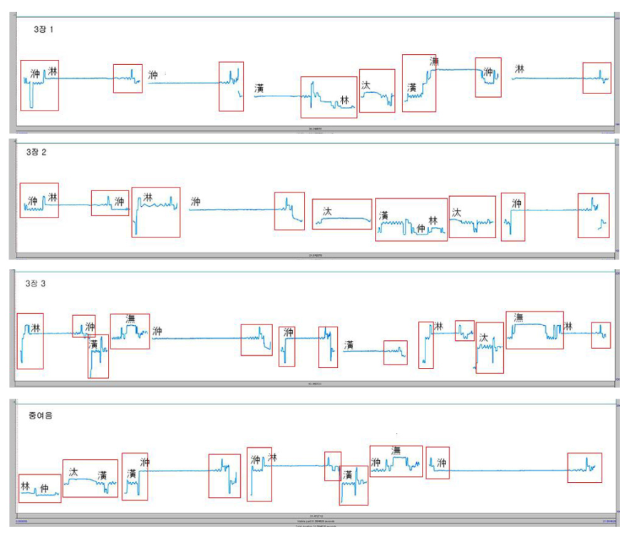
The first parts of the second and third jang (2장1 and 3장1) are identical with the exception of a short separator before and after 潕. Also there is a slight variation in the separator in the first part of third jang (3장1). Such slight variation in seperators prevents audience recognizing the repetition of the melody. The latter parts of the second and third line of third jang (3장2 and 3장3) are made entirely of separators, in contrast to the preceding parts in which the long notes were the main body and separators were used only to break such notes. The succession of separators evokes a feeling of escalating emotional turmoil, which is then followed by the intermezzo (중여음); the intermezzo’s long notes provide a calm respite from the building tension.

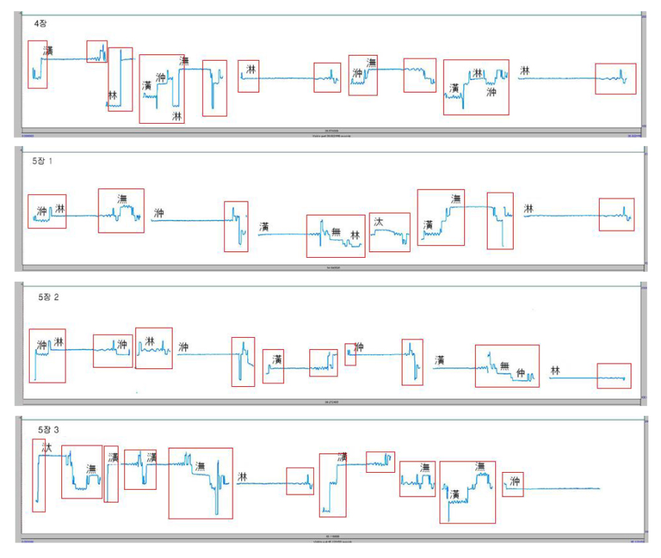
The first and second parts of the fifth jang (5장1 and 5장2) are identical to the first and second parts of the second jang (2장1 and 2장2). The fourth jang (4장) is almost entirely comprised of separators. The third part of the fifth jang (5장3) is again filled with separators and high notes that leads to a climax that is followed by an ending dispersed with separators.

Appendix:
This song uses a pentatonic scale comprised of the following notes. We measured the cents between notes after finding wavelengths through PRAAT. The following notation is one octave lower than the actual scale.

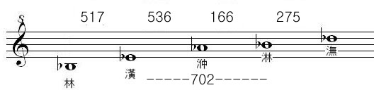

Name of note  (음명) | Range of min & max wavelength ( 진동수최저-최고 ) | Chosen Wavelength* (선택진동수)
淋 | 1083-1092 | 1090
潕 | 922 - 932 | 930
중 | 839 - 850 | 845
潢 | 617 - 625 | 620
林 | 454 - 461 | 460
*Chosen wavelength is based on the most frequently used wavelength.
**Determination of the cents for each note was calculated by the following formula:
y=log(a/b)x1200/log2
y=cents between two notes (wavelength)
a= wave length of the first note
b= wave length of the second note

